# Overview

This document contains the necessary information to build the Birch Sliding USB Joystick, including a customization guide, 3D printing guide, assembly guide, and instructions to test the finished joystick.

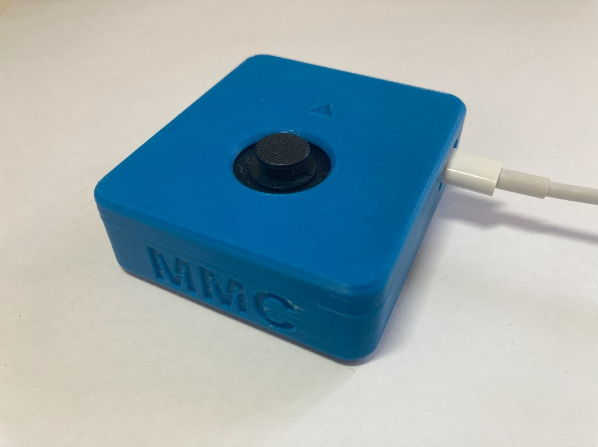

Contents

Overview 1

Maker Checklist 4

Maker To Do List 4

Items to Give to User 4

Tool List 5

Customization Guide 5

Joystick 5

Toppers 5

Mounting 5

3D Printing Guide 6

3D Printing Summary 6

3D Printing Settings 6

Joystick Enclosure - REQUIRED 6

Toppers and Mount Adapters* - OPTIONAL 6

Post-Processing 7

Customization Options 7

Examples of Quality Prints 7

Birch_Enclosure_Bottom 7

Birch_Enclosure_Top 8

Inner_Cover_Disk 8

Overlay 9

Joystick Camera Mount Adapter 9

Joystick toppers 9

Assembly Guide 10

Required Components 10

Required Tools 11

Required Personal Protective Equipment (PPE) 11

Joystick Assembly 12

Step 1: Position the overlay 12

Step 2: Position microcontroller headers 12

Step 3: Solder two header pins to board 13

Step 4: Solder remaining header pins to board 13

Step 5: Solder joystick to breakout board 14

Step 6: Position joystick headers 14

Step 7: Solder two header pins to board 15

Step 8: Solder remaining header pins to board 15

Step 9: Remove joystick and microcontroller 16

Wiring 16

Step 10: Position first wire 17

Step 11: Solder first wire 17

Step 12: Position and solder second wire 18

Step 13: Position and solder third wire 18

Step 14: Position and solder fourth wire 19

Step 15: Trim pins on the bottom of the board 19

Step 16: Trim excess wire on the top of the board 20

Step 17: Position microcontroller and joystick 21

Step 17: Solder pins on microcontroller and joystick breakout board 21

Step 18: Insert M3 nuts 22

Step 19: Screw protoboard into enclosure bottom 22

Step 20: Position inner disk 23

Step 21: Position enclosure top 23

Step 22: Screw enclosure together 24

Step 23: Plug in USB-C cable 24

Programming instructions 25

Testing 28

# Maker Checklist

This list provides an overview of the steps required to build and deliver the device.

## Maker To Do List

* Read through the Maker Guide to become familiar with required components, tools, supplies, safety gear, and overall assembly steps.
* Verify the user wants a USB joystick and ask the user if they would if they have a device to connect the joystick to.
  + [Xbox Adaptive Controller](https://www.xbox.com/en-CA/accessories/controllers/xbox-adaptive-controller)
  + PC (for gaming)
* Ask the user if they would like any joystick toppers.
* Ask the user if they would like a specific mounting solution.
* Talk to User about customization options (e.g., colour, any special requests, etc.).
* Order hardware components.
* 3D print all 3D printed components.
* Gather tools, supplies, and safety equipment.
* Assemble the device.
* Test device.
* Print “User Guide”

## Items to Give to User

* Assembled, tested device
* USB cable
* Any joystick toppers if requested.
* Any mount adapters if requested.
* “User Guide”

# Tool List

* Flush Cutters
* Wire Strippers
* Soldering Iron
* Philips Head Screwdriver

# Customization Guide

## Joystick

The enclosure can be printed in the user’s desired colour(s). Colour swaps can be done to further customize the joystick and make the forward arrow on the top stand out more.

## Toppers

3D printed joystick toppers can be added to the joystick. Current topper type include the small dome, medium dome, large dome, ring, and concave (shown left to right). These toppers can also be modified through the original design files.

## Mounting

Mount adapters can be added for custom mounting solutions. Current mounting options include nonslip pads, hook and loop fastener, a ¼-20 camera mount adapter, and a RAM-B mount adapter.

# 3D Printing Guide

## 3D Printing Summary

|  |  |  |
| --- | --- | --- |
| **Metrics** | **Joystick housing only**  **(No optional prints)** | **All files including optional prints** |
| Total Print Time (h:min) | 3:11 | 5:33 |
| Total Number of Components | 4 | 10 |
| Typical Total Mass (g) | 27.7 | 45.9 |
| Typical Number of Print Setups | 1 | 1 |

## 3D Printing Settings

### Joystick Enclosure - REQUIRED

|  |  |  |  |  |  |  |  |
| --- | --- | --- | --- | --- | --- | --- | --- |
| **Print File Name** | **Qty** | **Total Print Time (hr:min)** | **Mass (g)** | **Infill (%)** | **Support (Y/N)** | **Layer Height/ Nozzle Diameter(mm)** | **Notes (orientation, special settings, etc.)** |
| Birch_Enclosure_  Bottom | 1 | 1:46 | 14.9 | 20 | N | 0.2/0.4 |  |
| Birch_Enclosure_Top | 1 | 1:07 | 10.6 | 20 | N | 0.2/0.4 |  |
| Inner_cover_disk | 1 | 0:04 | 0.5 | 20 | N | 0.2/0.4 |  |
| Overlay | 1 | 0:14 | 1.7 | 20 | N | 0.2/0.4 |  |

### Toppers and Mount Adapters* - OPTIONAL

|  |  |  |  |  |  |  |  |
| --- | --- | --- | --- | --- | --- | --- | --- |
| **Print File Name** | **Qty** | **Total Print Time (hr:min)** | **Mass (g)** | **Infill (%)** | **Support (Y/N)** | **Layer Height/ Nozzle Diameter(mm)** | **Notes (orientation, special settings, etc.)** |
| Joystick_Camera_ Mount_Adapter | 1 | 0:54 | 8.5 | 20 | Y | 0.2/0.4 |  |
| Joystick_RAM_B_ Mount_Adapter | 1 | 1:01 | 9.3 | 20 | Y | 0.2/0.4 |  |
| Birch_Topper_Small_ dome | 1 | 0:08 | 0.6 | 20 | N | 0.2/0.4 |  |
| Birch_Topper_ Medium_dome | 1 | 0:17 | 1.7 | 20 | Y | 0.2/0.4 |  |
| Birch_Topper_Large_ dome | 1 | 0:37 | 4.9 | 20 | Y | 0.2/0.4 |  |
| Birch_Topper_Ring | 1 | 0:16 | 1.5 | 20 | Y | 0.2/0.4 | Print with ring parallel to print bed |
| Birch_Topper_ Concave | 1 | 0:10 | 1.0 | 20 | N | 0.2/0.4 |  |

## Post-Processing

* Remove any bumps or zits from the surface where the enclosure meets the lid.
* Remove any bumps or zits from both surfaces of the inner cover disk. If any binding occurs between the joystick and the inner cover disk when assembling, sand down this part.
* Remove any supports from camera mount or toppers if printed.

## Customization Options

* Joystick housing can be printed in multiple colours.
* The joystick camera mount adapter is an optional add-on for mounting using ¼-20 threads
* The optional topper prints can customize the joystick for different users

## Examples of Quality Prints

### Birch_Enclosure_Bottom

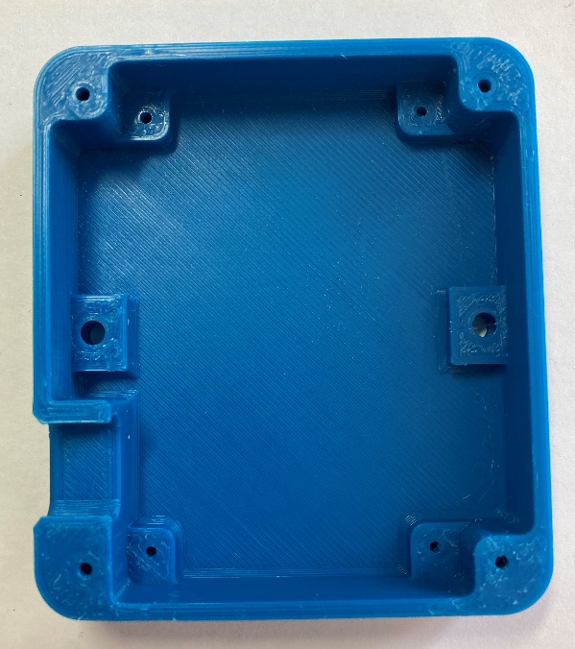 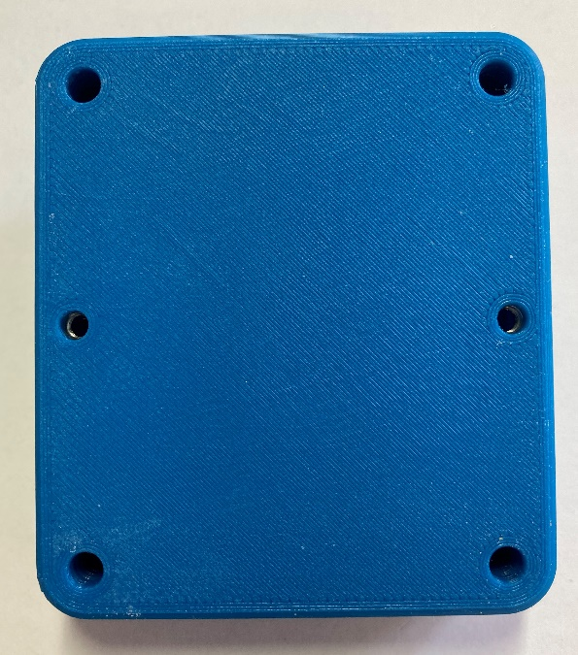

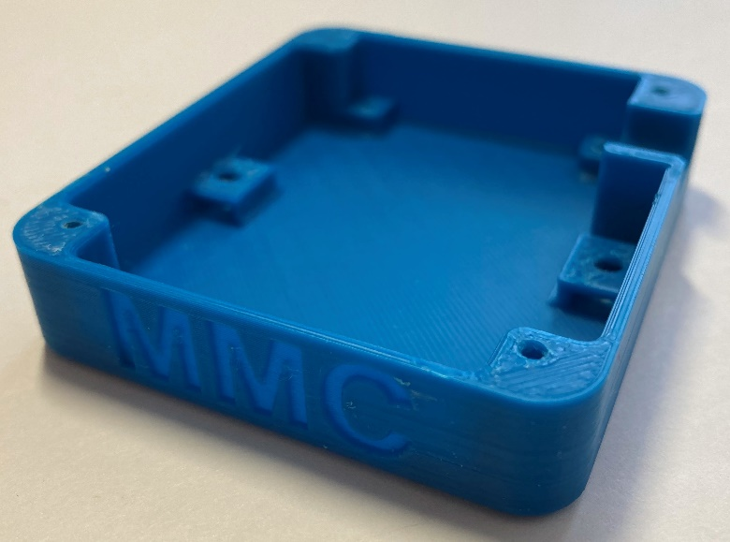

### Birch_Enclosure_Top

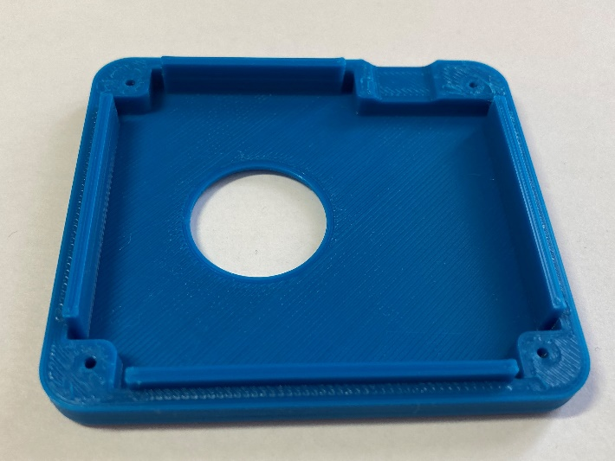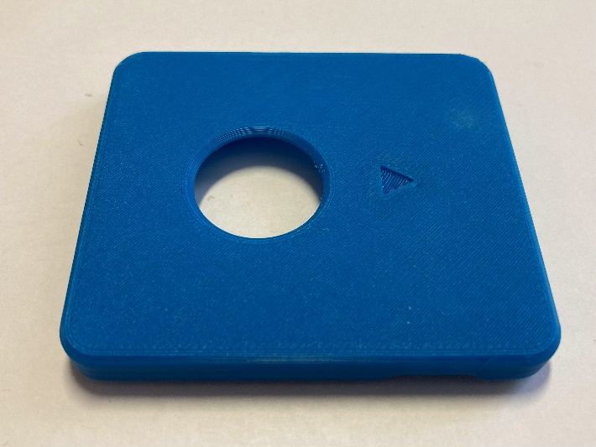

### Inner_Cover_Disk

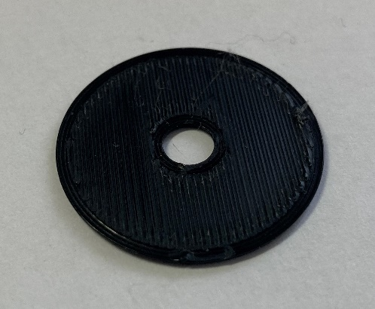

### Overlay

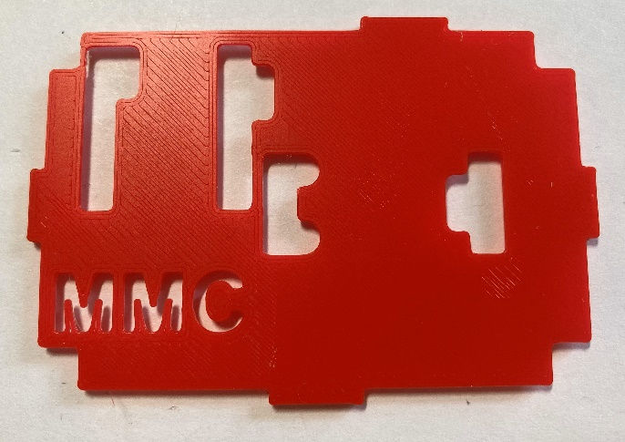 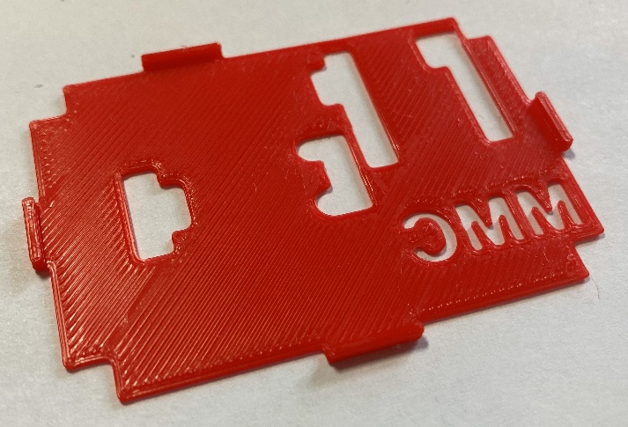

### Joystick Camera Mount Adapter

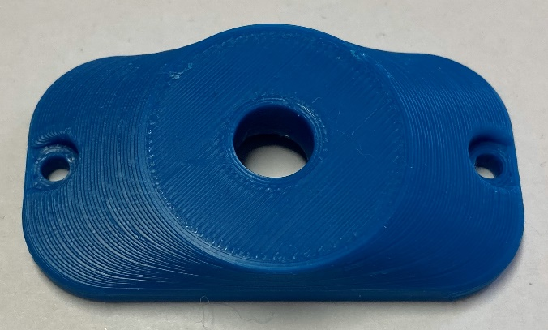 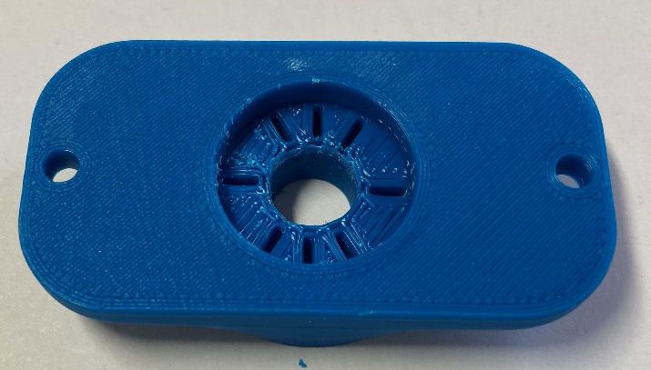

### Joystick toppers

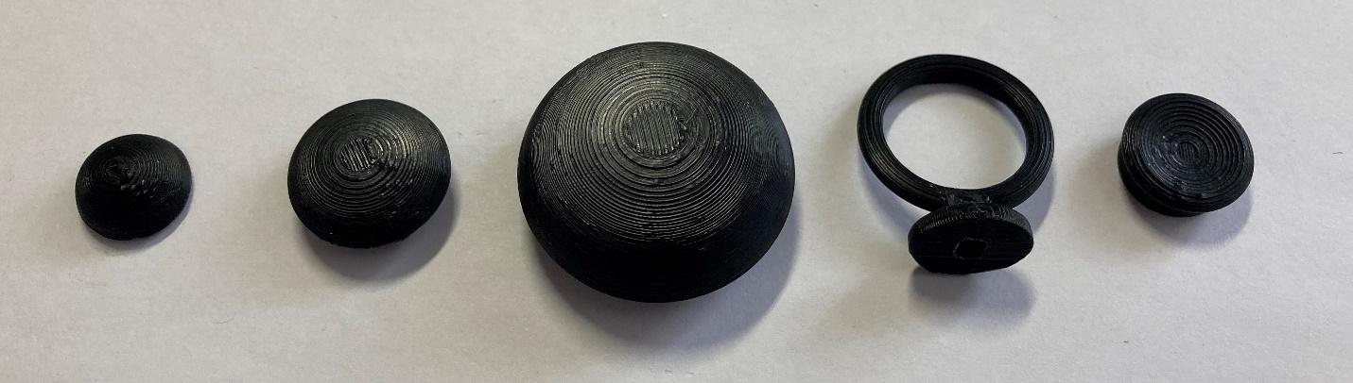

# Assembly Guide

## Required Components

|  |  |  |  |  |  |  |  |  |
| --- | --- | --- | --- | --- | --- | --- | --- | --- |
| **1** | Mini 2-Axis Analog Thumbstick | QTY 1 | **2** | Mini Thumbstick Breakout Board with included 8 pin male header | QTY 1 | **3** | Universal Proto-Board PCB 4cm x 6 cm | QTY 1 |
|  | | | *An assortment of components required for the sliding analog joystick assembly. These components are listed in the Bill of Materials (BOM) below. There are numbers beside each item.* | | | *An assortment of components required for the sliding analog joystick assembly. These components are listed in the Bill of Materials (BOM) below. There are numbers beside each item.* | | |
| **4** | SeeedStudio XAIO RP2040 with Included male headers | QTY 1 | **5** | 24 Gauge Wire or Protoboard Jumper Wires | 20 cm | **6** | M2 x 6 mm Self Tapping Screws | QTY 8 |
| *An assortment of components required for the sliding analog joystick assembly. These components are listed in the Bill of Materials (BOM) below. There are numbers beside each item.*  *Note: (do not use SAMD substitute) | | | *An assortment of components required for the sliding analog joystick assembly. These components are listed in the Bill of Materials (BOM) below. There are numbers beside each item.* | | |  | | |
| **7** | M3 Hex Nuts | QTY 2 | **8** | USB-C Cable | QTY 1 | **9** | 3D Printed Overlay | QTY 1 |
| A photo of two metal M3 hex nuts. | | | *An assortment of components required for the sliding analog joystick assembly. These components are listed in the Bill of Materials (BOM) below. There are numbers beside each item.* | | | Red 3D printed protoboard overlay, top view. | | |

|  |  |  |  |  |  |  |  |  |
| --- | --- | --- | --- | --- | --- | --- | --- | --- |
| **10** | Birch Inner Disk | QTY 1 | **11** | Birch Enclosure Bottom | QTY 1 | **12** | Birch Enclosure Top | QTY 1 |
| Small black 3D printed disk | | | Bottom of the enclosure, top view. The part is blue and was 3D printed. | | | **Top of the enclosure, top view. The part is blue and was 3D printed.** | | |

## Required Tools

* Flush Cutters
* Wire Strippers
* Soldering Iron
* Philips Head Screwdriver

## Required Personal Protective Equipment (PPE)

* Safety goggles

## Joystick Assembly

### Step 1: Position the overlay

|  |  |
| --- | --- |
| Place the 3D printed overlay on the protoboard.  **Ensure the text “MMC” is in the same orientation as the text on the protoboard.** | Universal protoboard PCB with a red 3D printed overlay on top. The overlay is thin and red and has holes in it for where components will be placed. The letters MMC are in the bottom left corner. |

### Step 2: Position microcontroller headers

|  |  |
| --- | --- |
| Place the two 7 pin male headers on the protoboard through the overlay from the top and place the XIAO microcontroller board on the headers.  **Ensure the USB port on the XIAO is oriented towards the nearest edge on the protoboard.** | Protoboard with red overlay, and male headers in their positions. Microcontroller and joystick breakout board have been removed.Protoboard with red overlay with XIAO microcontroller board placed in the top left corner. |

### Step 3: Solder two header pins to board

|  |  |
| --- | --- |
| Solder one pin on each of the headers to the protoboard, ensuring the XIAO microcontroller board remains flat and straight.  Note: the header pins from the XIAO board should be located at positions N08 – N14 and T08 – T14 (from below).  *(This only applies if the numbering on your board matches the photo)* | Bottom of the protoboard, showing the bottoms of the pins from the headers. Green circles indicate which two pins to solder. |

### Step 4: Solder remaining header pins to board

|  |  |
| --- | --- |
| Solder the remaining pins from the XIAO board to the protoboard. | Bottom of the protoboard, showing the bottoms of the pins from the headers. Green ovals indicate to solder remaining pins. |

### Step 5: Solder joystick to breakout board

|  |  |
| --- | --- |
| Insert the mini 2-axis analog thumbstick into the breakout board.  Solder the 6 pins, shown circled in red. | Close up of the joystick unit on the breakout board intended for use with standard headers.  Close up of the bottom of the joystick breakout board. The pads where the joystick pins go are circled in red.Close up of the bottom of the joystick breakout board. The pads where the joystick pins go have been soldered and are circled in red. |

### Step 6: Position joystick headers

|  |
| --- |
| Place the two 4 pin male headers on the protoboard through the overlay and place the joystick breakout board on the headers. If you have an 8 pin male header, gently break apart into two 4 pin headers, and then place headers onto the protoboard.  **Ensure the breakout board is text side up and the text is in the same orientation as the text on the overlay.** |
| Protoboard with overlay, showing male headers in their positions in the centre of the board. Protoboard with overlay, showing the joystick breakout board placed on top of headers in the middle of the protoboard. |

### Step 7: Solder two header pins to board

|  |  |
| --- | --- |
| Solder one pin on each of the headers to the joystick breakout board, ensuring the board remains flat and straight.  Note: the header pins from the joystick breakout board should be located at positions C06 - C09 and L06 – L09 (from below).  *(This only applies if the numbering on your board matches the photo)* | Bottom of the protoboard, showing the bottoms of the pins from the headers for the joystick board. Green circles indicate which two pins to solder. |

### Step 8: Solder remaining header pins to board

|  |  |
| --- | --- |
| Solder the remaining pins from the joystick breakout board to the protoboard. | Bottom of the protoboard, showing the bottoms of the pins from the headers. Green ovals indicate to solder remaining pins. |

### Step 9: Remove joystick and microcontroller

|  |  |
| --- | --- |
| Flip the board around and remove the joystick breakout board and the XIAO board from the headers. | Protoboard with red overlay, and male headers in their positions. Microcontroller and joystick breakout board have been removed. |

### Wiring

For the next steps, this is the overall wiring diagram. 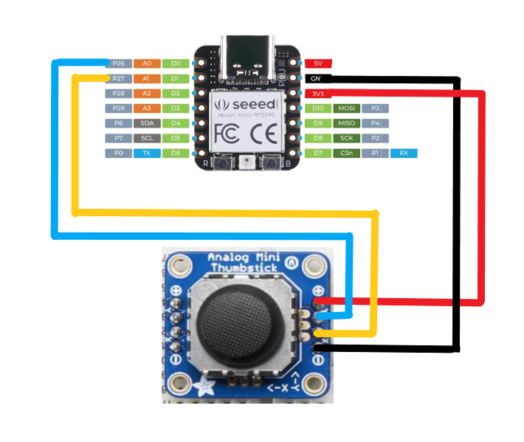

|  |  |
| --- | --- |
| **Seeed XIAO baord** | **Joystick breakout board** |
| 3v3 | + |
| GND | - |
| D0 | Y |
| D1 | X |

### Step 10: Position first wire

|  |  |
| --- | --- |
| Insert a wire from hole M12 to hole K09.  NOTE: All hole positions are in reference to the bottom of the board.  *If the numbers and letters on your protoboard don’t match this photo go from the holes next to: Joystick board, right header, top pin* **TO** *XIAO board, left header, 3rd pin from top.* | Bottom of the protoboard showing the placement of a yellow wire, with the ends of the wire circled in green. |

### Step 11: Solder first wire

|  |  |
| --- | --- |
| Solder the wire in place and create solder bridges from the wire ends to the adjacent pins. From M12 to N12, from K09 to L09.  *If the numbers and letters on your protoboard don’t match this photo, go from your new wire to the pin directly to the right.* | Bottom of the protoboard showing that the ends of a yellow wire are now soldered. The ends of the wire are circled in green. |

### Step 12: Position and solder second wire

|  |  |
| --- | --- |
| Insert a wire from M13 to K06.  Solder the wire in place and create solder bridges from the wire ends to the adjacent pins. From M13 to N13 and from K06 to L06.  *If the numbers and letters don’t match this photo go from the holes to the left of: Joystick board, right header, bottom pin* **TO** *XIAO board, left header, 2nd pin from top.* | Bottom of the protoboard showing the placement of a white wire, with the ends of the wire circled in green. |

### Step 13: Position and solder third wire

|  |  |
| --- | --- |
| Insert a wire from S14 to D08.  Solder the wire in place and create solder bridges from the wire ends to the adjacent pins. From S14 to T14 and from D08 to C08.  *If the numbers and letters don’t match this photo go from the holes next to: Joystick board, left header, 2nd pin from top* **TO** *XIAO board, right header, top pin.* | Bottom of the protoboard showing the placement of a red wire, with the ends of the wire circled in green. |

### Step 14: Position and solder fourth wire

|  |  |
| --- | --- |
| Insert a wire from S13 to D07.  Solder the wire in place and create solder bridges from the wire ends to the adjacent pins. From S13 to T13 and from D07 to C07.  *If the numbers and letters don’t match this photo go from the holes next to: Joystick board, left header, 3rd pin from top* **TO** *XIAO board, right header, 2nd pin from top.* | Bottom of the protoboard showing the placement of a second red wire, with the ends of the wire circled in green. |

### Step 15: Trim pins on the bottom of the board

|  |  |
| --- | --- |
| On the bottom of the board, trim the header pins for both the joystick board and the XIAO board, as shown circled in green. | Close up of the protoboard showing the long header pins on the bottom of the board. These pins are circled in green.  Close up of the protoboard showing the long header pins on the bottom of the board, and indicating where to cut them with a green dashed line. |

### Step 16: Trim excess wire on the top of the board

|  |  |
| --- | --- |
| On the top of the board, trim the extra length from the jumper wires, as shown circled in green.  **Do no trim the male headers on the top of the board.** | Close up of the protoboard from the side view, showing the long wires sticking out on the top of the board. These wires are circled in green.  Close up of the protoboard showing the long wires sticking out on the top of the board. Dashed lines show where to cut the wires. |

|  |
| --- |
| Below is how the board should look once the wires and bottoms of headers are trimmed. |
| Close up of the bottom of the protoboard with all of the wires solders and headers trimmed.  Close up of the top of the protoboard with male headers in their positions and wires trimmed. |

### Step 17: Position microcontroller and joystick

|  |  |
| --- | --- |
| If you wish to re-use the 3D printed overlay you may remove it, or it may be left on.  Place the XIAO microcontroller board and the joystick breakout board onto their respective headers.  **Ensure the USB port on the XIAO is oriented towards the nearest edge on the protoboard.**  **Ensure the text on the joystick board is in the same orientation as the text on the overlay/protoboard.** | Top of the protoboard with red overlay, and with microcontroller and joystick breakout board in their positions but not soldered. |

### Step 17: Solder pins on microcontroller and joystick breakout board

|  |  |
| --- | --- |
| Solder the XIAO microcontroller board and the joystick breakout board to their headers.  Ensure the boards stay flat while soldering. | Top of the protoboard with red overlay, and with microcontroller and joystick breakout board in their positions and soldered. Green ovals show where to solder. |

### Step 18: Insert M3 nuts

Take the two M3 nuts and slide them into the slots inside the enclosure as shown.

|  |  |
| --- | --- |
| Bottom of sliding joystick enclosure, showing two M3 nuts beside the nut slots, with two red arrows indicating the direction to slide the nuts into the slots. | Bottom of the sliding joystick enclosure, showing two nuts in the nut slots. Two red circles show the locations of the nuts. These are used for mounting. |

### Step 19: Screw protoboard into enclosure bottom

|  |  |
| --- | --- |
| Take the protoboard and the bottom of the 3D printed enclosure and insert M2 screws in each of the four corners of the board, as shown circled in red. | Protoboard installed in the bottom of the 3D printed enclosure. Red circles show the locations of the screw holes. |

### Step 20: Position inner disk

|  |  |
| --- | --- |
| Remove the joystick topper.  Place the 3D printed inner disk on the joystick, around the joystick post.  Replace joystick topper. | Close up of the joystick unit without the joystick topper. Close up of the joystick unit without the joystick topper. A black disk has been placed on the joystick peg. Close up of the joystick unit with the joystick topper and black disk. |

Note: if the joystick is difficult to move after this step, sand down the inner cover disk so it is smooth and does not have bumps or zits.

### Step 21: Position enclosure top

|  |  |
| --- | --- |
| Place the 3D printed enclosure lid on top of the enclosure base. | Top view of the joystick, with the top of the enclosure installed. |

### Step 22: Screw enclosure together

|  |  |
| --- | --- |
| Flip the joystick around and insert an M2 screw into each of the 4 screw holes circled in red and tighten them. | Bottom of the 3D printed enclosure, with red circles showing the locations of the screw holes. |

### Step 23: Plug in USB-C cable

|  |  |
| --- | --- |
| Plug the USB C cable into the joystick, and proceed to programming the joystick. | Top view of the joystick, with the USB C cable plugged into it. |

## Programming instructions

1. Setup Arduino IDE
   1. Download Arduino IDE for your operating system at <https://www.arduino.cc/en/software>
   2. Install Arduino IDE
2. Setup Core
   1. Open Arduino IDE
   2. Click on **File -> Preferences**
   3. Locate the text field that says **Additional Boards Manager URLs** beside it.
   4. Copy and paste the following link into the field as a new line: <https://github.com/earlephilhower/arduino-pico/releases/download/global/package_rp2040_index.json>

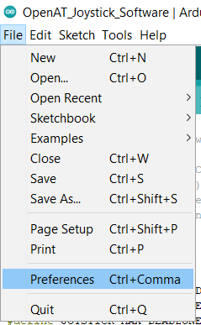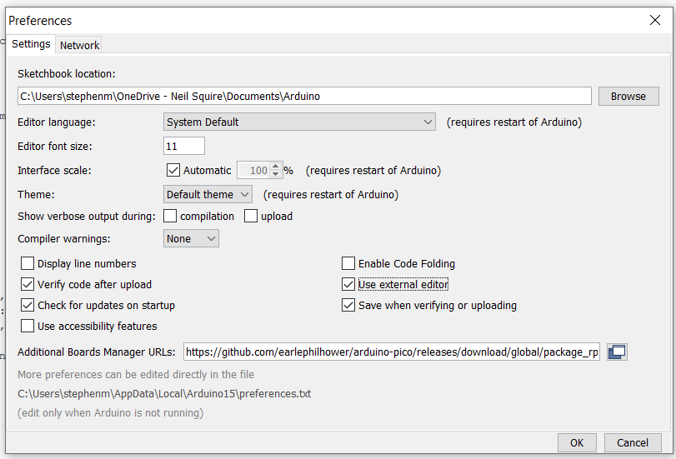

* 1. Click on **OK**
  2. Restart the Arduino IDE
  3. Open the **Boards Manager** option from the **Tools-> Board-> Boards Manager..., search for “Seeed Xiao” and select the package called “Raspberry Pi Pico/RP2040” by Earle F. Philhower, III**

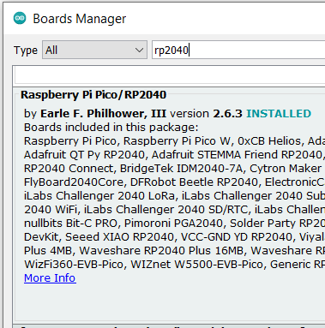

* 1. Select **Seeed XIAO RP2040** from **Tools -> Board** **-> Raspberry Pi RP2040** **Boards** menu.

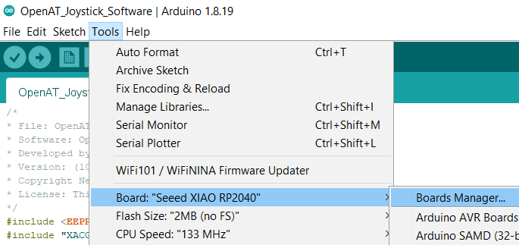

* 1. Click on **Tools -> USB Stack** and select **Adafruit TinyUSB**

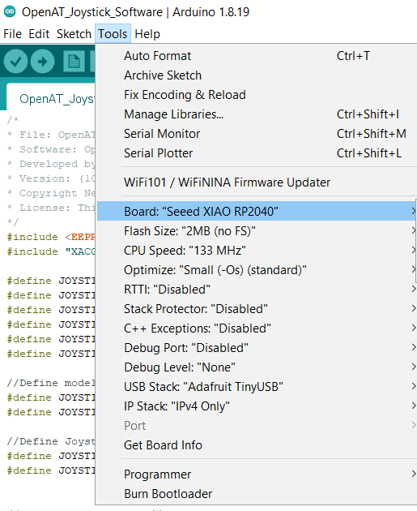

More Information: <https://wiki.seeedstudio.com/XIAO-RP2040-with-Arduino/>

1. Upload the Code to the joystick
   1. Open OpenAT_Joystick_Software_Birch.ino with Open Arduino ID.
   2. Select **Seeed XIAO RP2040** from **Tools -> Board** **-> Raspberry Pi RP2040** **Boards** menu.
   3. Connect the joystick using the USB cable to the computer.
   4. Select the correct port from **Tools -> Port** menu.
   5. Verify and upload the code.

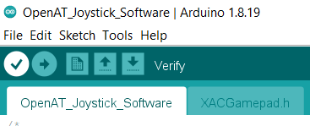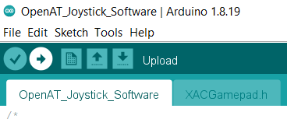

## Testing

1. Connect the joystick using the USB C cable to the computer.
2. If using Windows, open “Set up USB Game Controllers” from the Control Panel. You can find this by searching your computer in the search bar next to the Windows icon.
3. Ensure that the joystick is registered as a game controller and select your joystick from the list and go to “Properties”.
4. Move your joystick and observe the movement of the cross hatch in the “Axes” window. Ensure it moves in the proper directions when you move the joystick (the arrow points in the up direction). If not, open the joystick and check your connections.

## Optional – Mounting

### Table Top Mounting – Non-Slip Pads

|  |  |
| --- | --- |
| If using the joystick on a tabletop, and height of the joystick is not a concern, nonslip pads can be added in each of the four corners on the bottom, as shown. |  |

### Table Top Mounting – Hook and Loop Fastener

|  |  |
| --- | --- |
| If using the joystick on a tabletop or other surface with hook and loop fasteners, such as Velcro, stick the hook side (rough side) to the joystick and the loop side (soft side) to the surface to mount to. | Bottom of the joystick with hook and loop fastener attached to the bottom. The hook side is shown stuck to the joystick. |

### Camera Mount

To mount the joystick on a camera mount, the optional Joystick Camera Mount Adapter can be used.

|  |  |
| --- | --- |
| Step 1 Flip the camera mount adapter around to reveal the recess with small slots.  Ensure all supports are removed from the 3D print. | Blue 3D printed part for the camera mount adapter. There are two holes on the sides and one hole in the middle with small slots around it. |

|  |  |
| --- | --- |
| Step 2 Insert the tee nut, lining up the barbs with the small slots in the 3D print. | Blue 3D printed part for the camera mount adapter, with a tee nut sitting inside of it, not fully inserted. |

|  |  |
| --- | --- |
| Step 3 Flip the part around and screw in a ¼-20 hex bolt. | Blue 3D printed part for the camera mount adapter, with a hex bolt being screwed into it. There is a white arrow showing to screw in the hex bolt clockwise. |

|  |  |
| --- | --- |
| Step 4 Tighten the bolt until the tee nut is seated down as far as possible.  (Alternatively, if you do not have acces to a bolt, the tee nut may be press fit as long as it sits flush with the 3D print.) | Top of the camera mount adapter, with a hex bolt fully screwed into it. There is a white arrow showing to screw in the hex bolt clockwise. Bottom of the camera mount adapter, showing a tee nut fully installed into the 3D print, and sitting flush. There are two arrows pointing down to indicate that the tee nut is all the way down. |

|  |  |
| --- | --- |
| Step 5 Using 2 M3 screws, screw the camera mount adapter to the bottom of the joystick in the two middle holes. | The camera mount adapter screwed into the bottom of the Sliding Analog Thumbstick, using two small screws. Both the camera mount adapter and the joystick are light blue. The screws are circled in red. |